**Step 1: Enable WSL 2**

Windows Subsystem for Linux (WSL) 2 is a prerequisite for Docker Desktop on Windows. It provides a lightweight Linux kernel for compatibility and performance improvements.

Open PowerShell as Administrator and run:

wsl –install

**Step 2: Install Docker Desktop**

1. Download [Docker Desktop for Windows](https://docs.docker.com/desktop/install/windows-install/) from the official Docker website.
2. Run the installer and follow the on-screen instructions.
3. Launch Docker Desktop after installation. You might be prompted to log out and back in, or to enable the WSL 2 feature.

**Step 3: Configuration and Verification**

After installation, it’s time to configure and verify Docker Desktop.

1. Right-click on the Docker icon in the system tray and select Settings.
2. Review the settings and adjust them according to your needs. For most users, the default settings are sufficient.
3. To verify Docker is installed correctly, open a terminal (Command Prompt or PowerShell) and run:

docker –version

1. This command should display the Docker version, indicating a successful installation.
2. Run the Hello World container to ensure everything is set up correctly:

docker run hello-world

1. If you see a welcome message, congratulations! Docker is now installed and running on your Windows system.

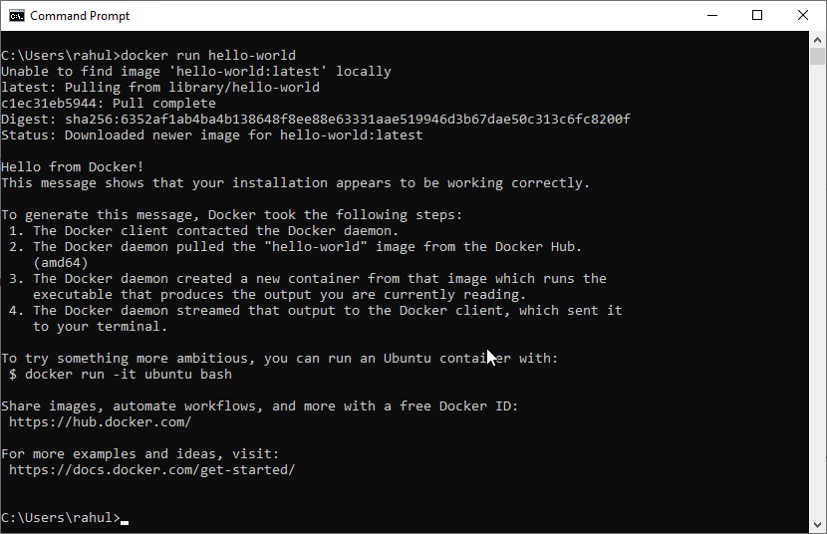

# **Install Docker Engine on Ubuntu**

### [**Uninstall old versions**](https://docs.docker.com/engine/install/ubuntu/#uninstall-old-versions)

Before you can install Docker Engine, you need to uninstall any conflicting packages.

Distro maintainers provide unofficial distributions of Docker packages in APT. You must uninstall these packages before you can install the official version of Docker Engine.

The unofficial packages to uninstall are:

* docker.io
* docker-compose
* docker-compose-v2
* docker-doc
* podman-docker

Moreover, Docker Engine depends on containerd and runc. Docker Engine bundles these dependencies as one bundle: containerd.io. If you have installed the containerd or runc previously, uninstall them to avoid conflicts with the versions bundled with Docker Engine.

Run the following command to uninstall all conflicting packages:

for pkg in docker.io docker-doc docker-compose docker-compose-v2 podman-docker containerd runc; do sudo apt-get remove $pkg; done

apt-get might report that you have none of these packages installed.

Images, containers, volumes, and networks stored in /var/lib/docker/ aren't automatically removed when you uninstall Docker. If you want to start with a clean installation, and prefer to clean up any existing data, read the [uninstall Docker Engine](https://docs.docker.com/engine/install/ubuntu/#uninstall-docker-engine) section.

## [Installation methods](https://docs.docker.com/engine/install/ubuntu/#installation-methods)

You can install Docker Engine in different ways, depending on your needs:

* Docker Engine comes bundled with [Docker Desktop for Linux](https://docs.docker.com/desktop/install/linux-install/). This is the easiest and quickest way to get started.
* Set up and install Docker Engine from [Docker's apt repository](https://docs.docker.com/engine/install/ubuntu/#install-using-the-repository).
* [Install it manually](https://docs.docker.com/engine/install/ubuntu/#install-from-a-package) and manage upgrades manually.
* Use a [convenience script](https://docs.docker.com/engine/install/ubuntu/#install-using-the-convenience-script). Only recommended for testing and development environments.

### [**Install using the apt repository**](https://docs.docker.com/engine/install/ubuntu/#install-using-the-repository)

Before you install Docker Engine for the first time on a new host machine, you need to set up the Docker repository. Afterward, you can install and update Docker from the repository.

1. Set up Docker's apt repository.

# Add Docker's official GPG key:

sudo apt-get update

sudo apt-get install ca-certificates curl

sudo install -m 0755 -d /etc/apt/keyrings

sudo curl -fsSL https://download.docker.com/linux/ubuntu/gpg -o /etc/apt/keyrings/docker.asc

sudo chmod a+r /etc/apt/keyrings/docker.asc

# Add the repository to Apt sources:

echo \

"deb [arch=$(dpkg --print-architecture) signed-by=/etc/apt/keyrings/docker.asc] https://download.docker.com/linux/ubuntu \

$(. /etc/os-release && echo "$VERSION_CODENAME") stable" | \

sudo tee /etc/apt/sources.list.d/docker.list > /dev/null

sudo apt-get update

Install the Docker packages.

sudo apt-get install docker-ce docker-ce-cli containerd.io docker-buildx-plugin docker-compose-plugin

Verify that the Docker Engine installation is successful by running the hello-world image.

$

sudo docker run hello-world

1. This command downloads a test image and runs it in a container. When the container runs, it prints a confirmation message and exits.

You have now successfully installed and started Docker Engine.